**ANALYSING THE PERFORMANCE & EFFICIENCY OF THE RADISSON HOTELS USING DATA VISUALIZATION TECHNIQUES**

**TEAM LEADER :** MEJISHA THERAS P

**TEAM MEMBER :** SUNMATHI V

**TEAM MEMBER :** STEFFY P

**TEAM MEMBER :** NANCY SUJAYA S

**TEAM MEMBER :** ASHIKA D

**INTRODUCTION**

**1.1 Overview**

Radisson owns multiple five-star hotels across India.They have been in the hospitality industry for the past 100 years In this project we analyze about how Radisson hotels losing it's market share and revenue in the luxury / business hotels category. Market share is the percent of total sales in an industry .Market share is calculated by taking the companies sales over the period and dividing it by the total sales of the industry over the same period. This metric is used to give a general idea of the size of a company in relation to it's market and it's competitors.

**1.2 Purpose**

Our project is useful for the people to know more about understanding the market share and their strategy goals by offering it's customers innovative technology ,strengthening customer loyalty, hiring talented employees, and acquiring competitors. It can influence it's operations significantly,namely,it's share performance,scalability,and prices that it can offer for it's products or services.Technically if we simply put the purpose of our project is shows the size of a company,a useful metric in illustrating a company's dominance and competitiveness in a given field.

**2. PROBLEM DEFINITION AND DESIGN THINKING**

**2.1 EMPATHY MAP**

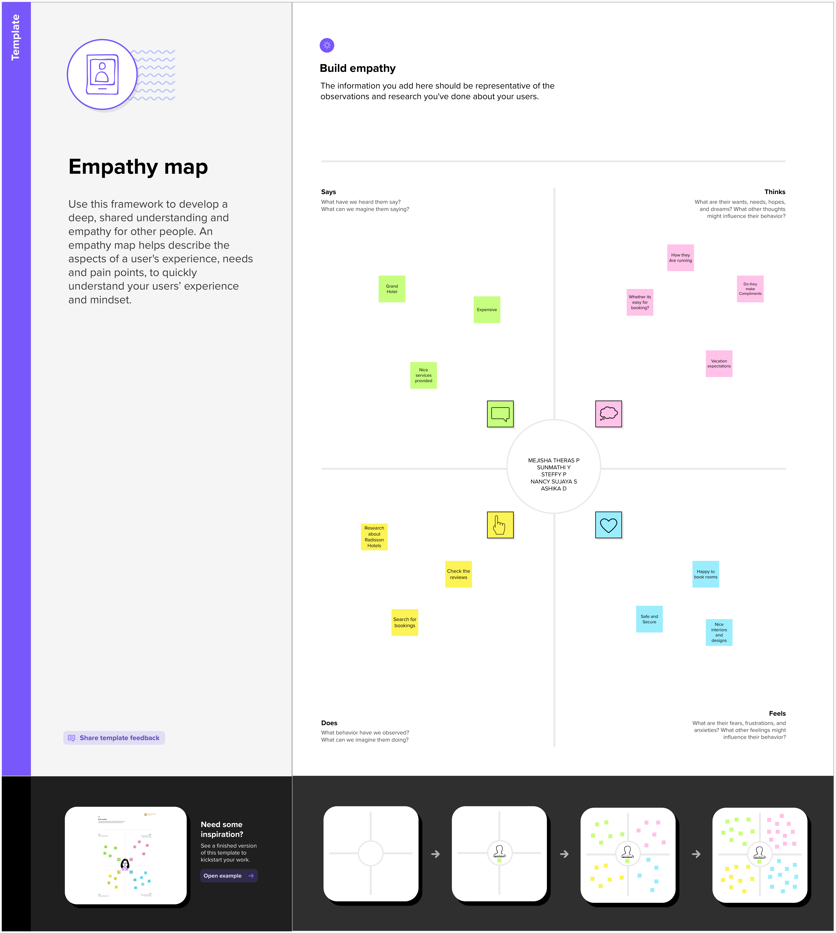

**2.2 IDEATION & BRAINSTORMING MAP**

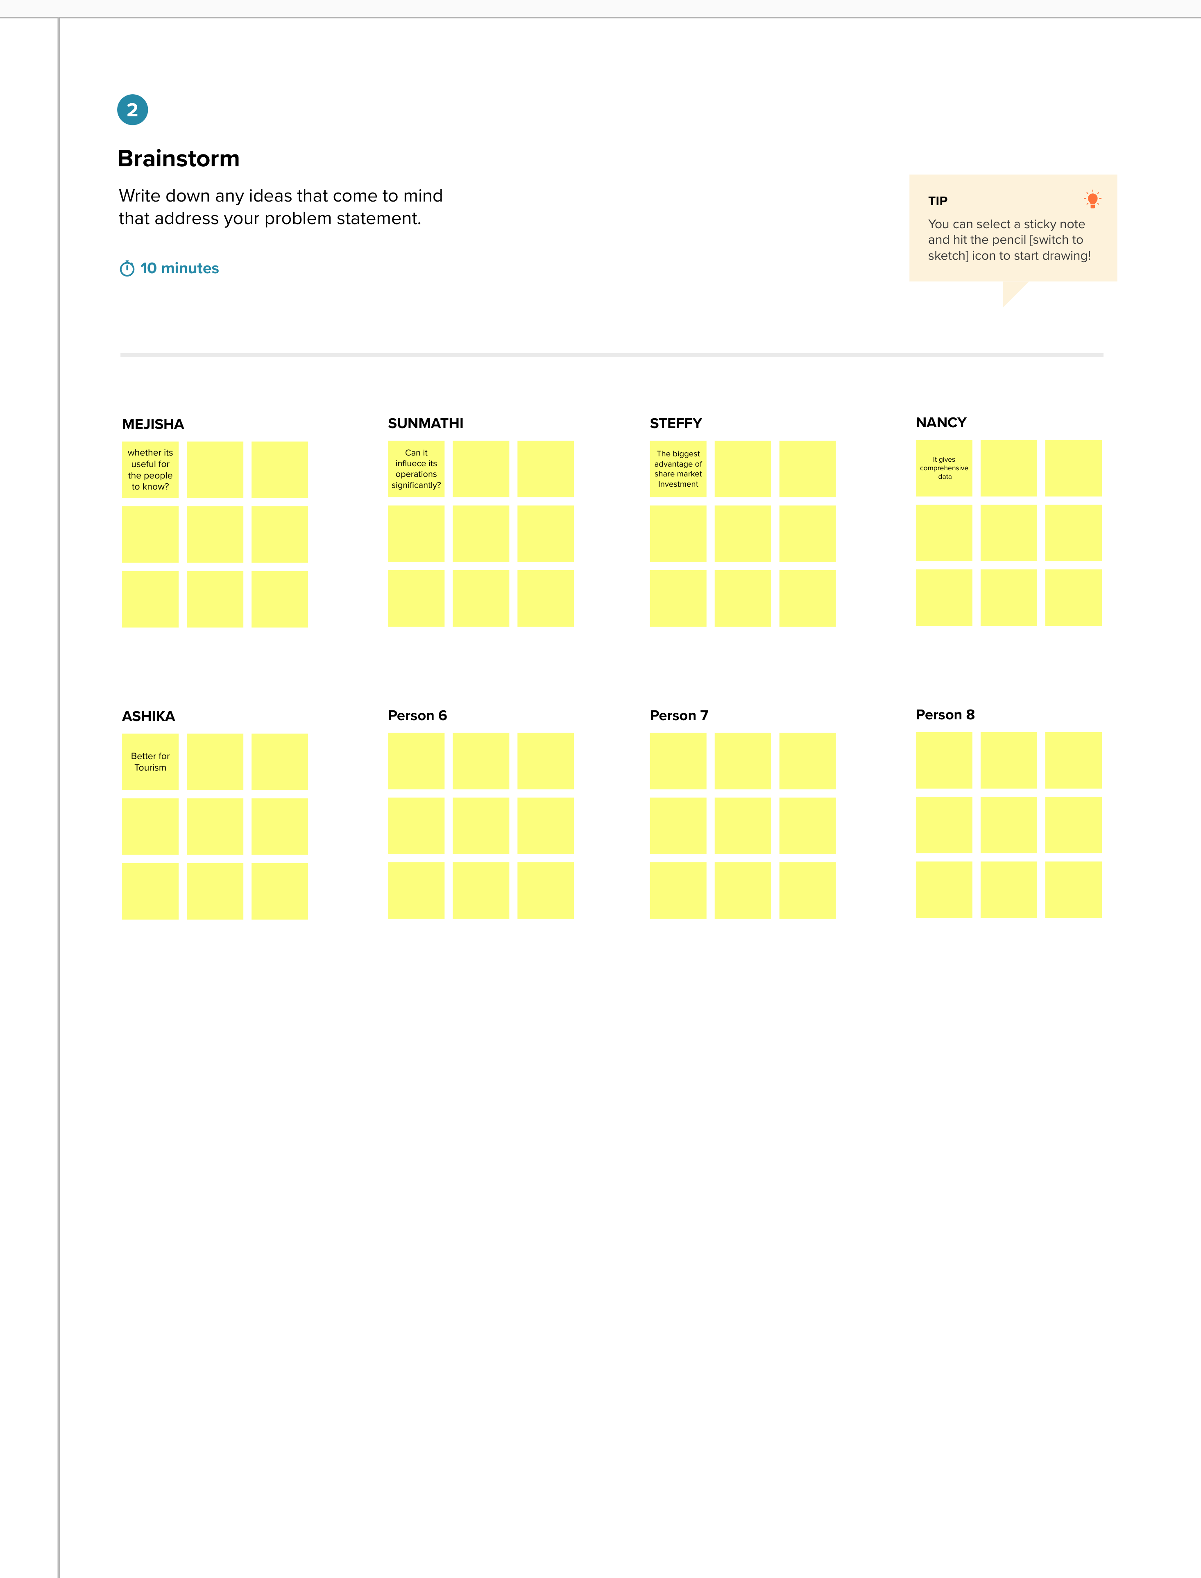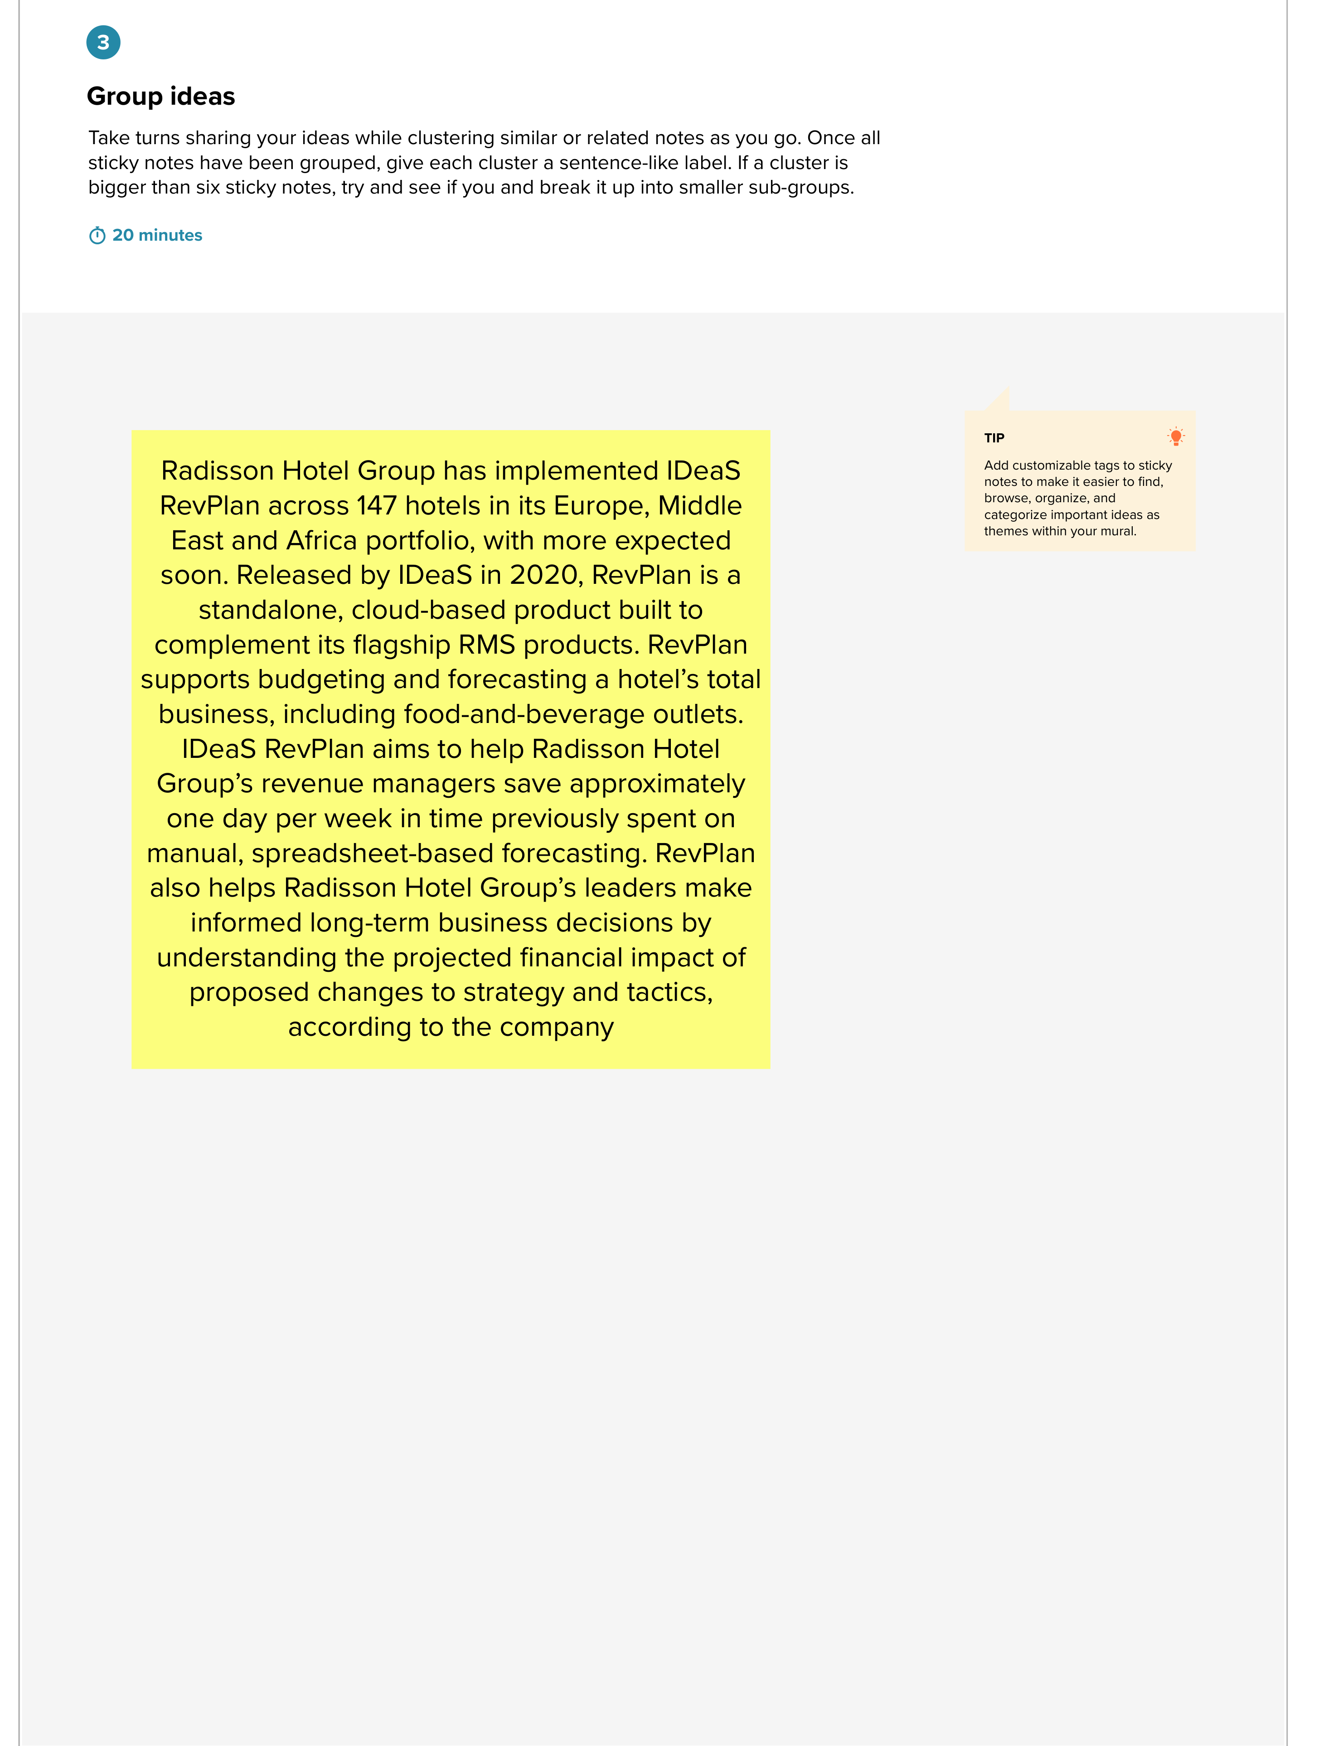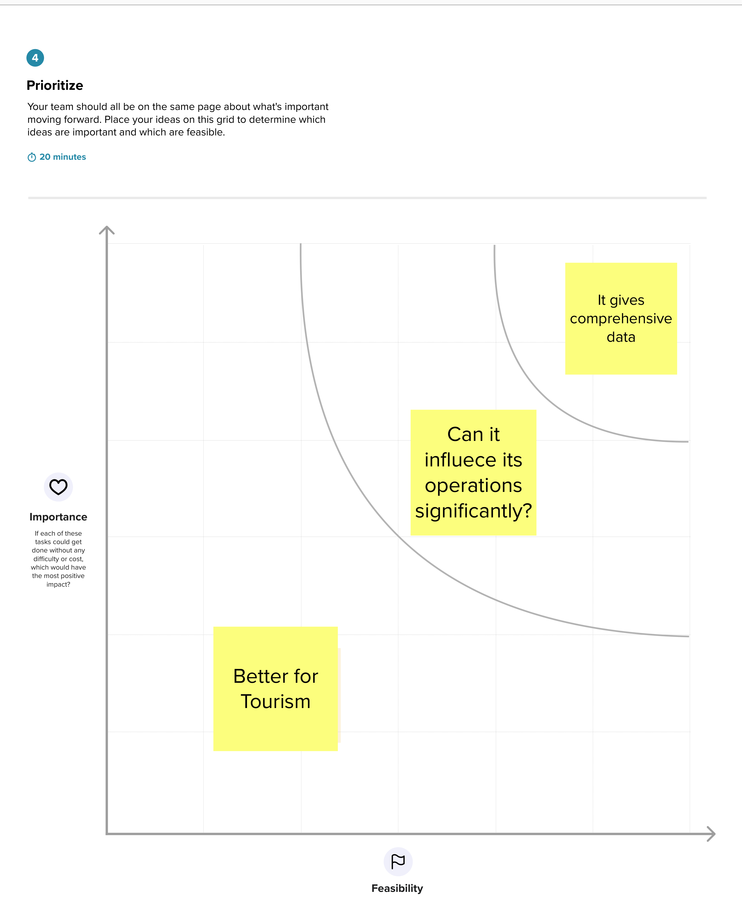

**3. RESULT**

**3.1 DASHBOARD**

A dashboard is a collection of several views, letting you compare a variety of data simultaneously.

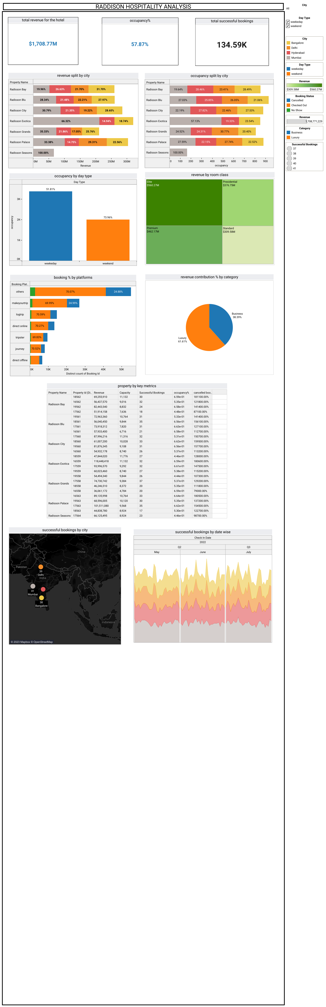

**3.2 STORY**

A story is a sheet, so the methods you use to create, name, and manage worksheets and dashboards also apply to stories. At the same time, a story is also a collection of sheets, arranged in a sequence. Each individual sheet in a story is called a story point.

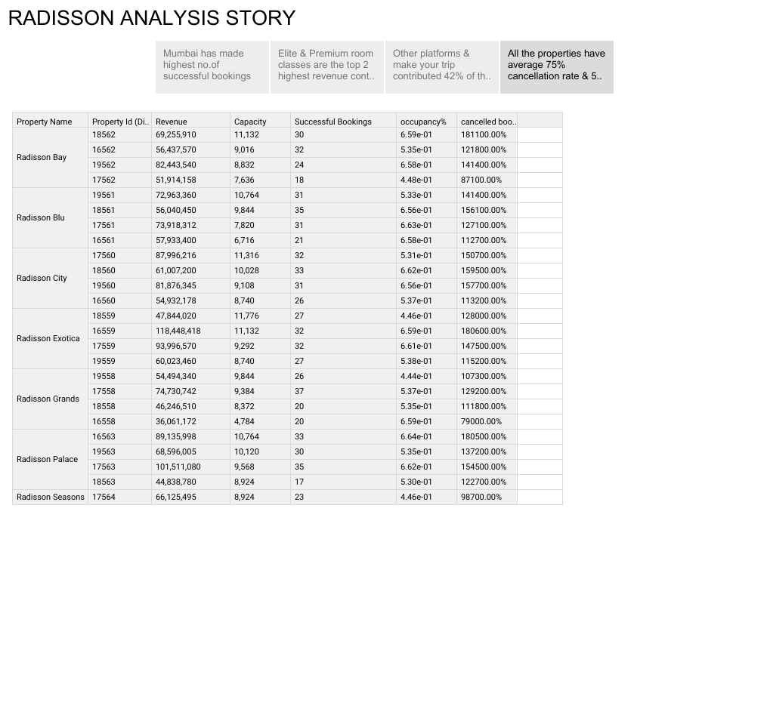

**4. ADVANTAGES AND DISADVANTAGES**

Advantages:

The biggest advantage of share market investment is that it has the potential to generate inflation-beating returns within a short period of time as compared to other investment avenues like bank FDs, saving accounts etc.Market share increases can allow a company to achieve greater scale with its operations and improve profitability. A company can try to expand its share of the market, either by lowering prices, using advertising, or introducing new or different products. In addition, it can also grow the size of its market share by appealing to other audiences or demographics.

Disadvantage:

It is an absolute figure. So, looking at one year’s data may be deceptive as we can know the current position of the firm but can get no clue about its growth or decline. Only when we see past years’ data and calculate the change in market share, we can trace its real performance.Also the disadvantages of a market economy are intense competition, poor working conditions, environmental degradation, and economic disparities.

**5. APPLICATIONS**

This project gives the comprehensive details about the market share which includes strategy making,increassing the stock management and etc.A company that maintains its share over time is growing its revenues in line with its competitors. But an increase shows a speedier, market-leading, boost in revenue. It also provide us insights to make better business decisions.

**6. CONCLUSIONS**

The hotel industry is a broad category of businesses that provide lodging services for travellers and tourists. This can include a wide range of establishments, from luxury resorts to budget-friendly motels, as well as extended stay hotels, boutique hotels, and more. Hotels can be found in nearly every corner of the world, and are often a major component of the tourism and travel industry in a given area.Thus, it can be concluded that the company strives for sustaining its spot in the market and surpassing its competitors. It is achieved through a thorough approach towards marketing mix and an attentive approach to the staff and clients. Despite the intense rivalry within the industry, Radisson Blu has been able to attain a great market share and achieve customer loyalty.

**7. FUTURE SCOPE**

The Tourism and Hotel Market has been comprehensively examined in a new research report published by Absolutereports.com. This report provides a complete overview of the market scenario, including latest trends, CAGR status, opportunities, market risk, and market-driven factors. Additionally, the report includes a primary review of the market, detailing the industry chain structure, developing policies, and categorization of product types, applications, major players, and sectors. The report also analyses the top companies in the industry for their company profile, product portfolio, capacity, price, expenses, and revenue.The hospitality and tourism industry has been witnessing a healthy growth number and accounted for 7.5% of the GDP. India is a part of the top 100 clubs on Ease of Doing Business (EoDB) and ranks 1st in the greenfield FDI ranking globally and to strengthen the cruise tourism sector, the Government of India (GoI) has selected Chennai, Goa, Kochi, Mangalore, and Mumbai ports to develop them as cruise tourism hubs. These terminals will have facilities like hospitality, retail, shopping, and restaurants.

Hospitality is one of the fastest growing industries in the world today. According to the Ernst & Young report, Global Hospitality Industry Insights 2016, the hospitality industry is going to be the single largest employer globally, contributing 1 among 11 jobs generated. The World Travel & Tourism Council calculated that tourism generated 8.31 lakh crore (US$120 billion) or 6.3 percent of the nation’s GDP in 2015 and supported 37.315 million jobs, 8.7 percent of its total employment. The sector is predicted to grow at an average annual rate of 7.5 percent to 18.36 lakh crore (US$270 billion) by 2025 (7.2 percent of GDP). This makes India one of the fastest growing tourism industries over the next decade.